Quaternary-Amino functionalized Swellable Organically Modified Silica for the removal of methyl orange from water
Lorenzo Maccarino¹, Geo Paul¹, Leonardo Marchese¹, Chiara Bisio^{1,2}
¹ Dept. of Science and Technological Innovation, Università del Piemonte Orientale, Viale Teresa Michel 11, Alessandria, 15121, Italy.
² CNR-SCITEC Institute of Chemical Science and Technology “Giulio Natta”, Via G. Venezian 21, Milano, 20133, Italy.
lorenzo.maccarino@uniupo.it

Organic dyes, prevalently found as textile industries effluents, pose significant environmental risks due to their carcinogenic and mutagenic properties. Among the different classes of dyes, those containing azo groups, such as methyl orange (MO), collect increasing concerns. Their contamination of freshwater necessitates effective remediation strategies to protect human health and aquatic ecosystems. In this respect, adsorption methods offer a promising solution for efficient and cost-effective dye removal [1]. Different solids can be used for adsorption purposes, including synthetic zeolites, clays, silicas, titania particles, nanocomposites, polymer resins, various biomass-based adsorbents, activated carbons and hybrid materials [2]. Swellable Organically Modified Silicas (SOMS) are hybrid materials obtained by sol-gel process using bis(trimethoxysilylethyl)benzene (BTEB) as the silica source [2]. SOMS are able to swell in organic solvents such as ethanol, acetonitrile, and acetone and this can improve adsorption capabilities. SOMS can also be functionalized with a positive quaternary amine silane (TMA), to impart a positive charge to the final material (referred to as QA-SOMS) [3-4]. SOMS and QA-SOMS with different TMA:BTEB ratios were prepared and characterized by a multi-technique approach to determine their composition (CHN elemental analysis), morphology (by SEM), structure (by XRD), texture (by N₂ physisorption), thermal properties (TGA), chemical structure (by FT-IR and ss-NMR) and surface charge (by zeta potential analysis). A schematic chemical structure of QA-SOMS obtained from ss-NMR spectra is reported in Figure 1. The MO adsorption performance of the samples was tested. It was observed that increasing the amount of quaternary amino groups in the QA-SOMS materials resulted in an increase in the amount of MO adsorbed. For the QA-SOMS with the highest TMA:BTEB ratio (QA-SOMS 2:1), rapid MO adsorption in large amounts up to 720 mg/g was observed (Figure 2).
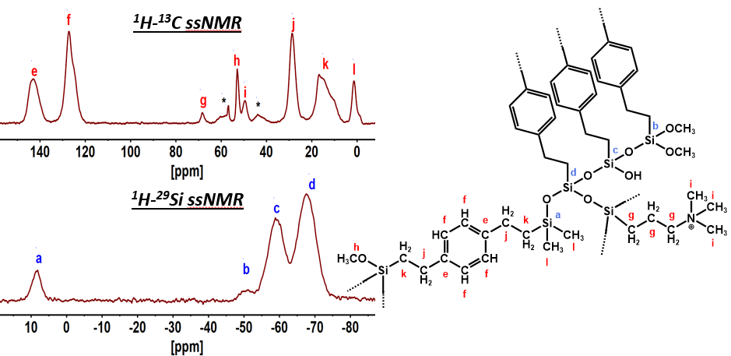  Figure 1. QA-SOMS schematic chemical structure obtained from ss-NMR. | 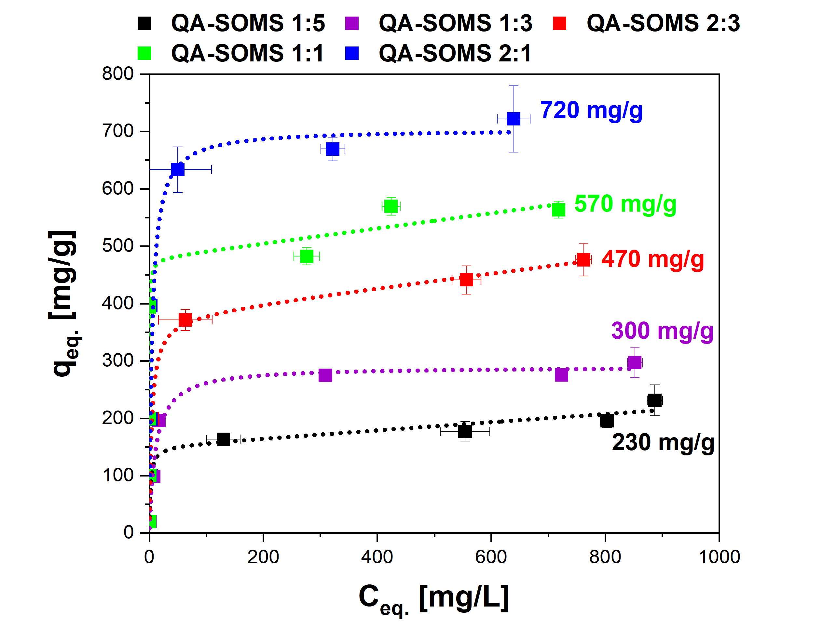  Figure 2. MO adsorption isotherms for QA-SOMS materials with varying TMA:BTEB ratios.

[1] H. O. Alsaab et al. J. of Colloid and Interface Science 679 (2025) 555-568
[2] L. Maccarino et al. Microporous and Mesoporous Materials 375 (2024) 113178
[3] V. Miglio et al. J. Phys. Chem. C 128, 5 (2024) 2179-2189
[4] E. K. Stebel et al. Environ. Sci.: Water Res. Technol. 5 (2019) 1854-1866

