Magnetic swellable organically modified silicas for the removal of organic dyes from aqueous media
Lorenzo Maccarino¹, Ibtissame Sidane², Sawssen Slimani^{2,3}, Leonardo Marchese¹, Davide Peddis^{2,3}, Chiara Bisio^{1,4}
¹ Dept. of Science and Technological Innovation, Università del Piemonte Orientale, Viale Teresa Michel 11, Alessandria, 15121, Italy.
² Department of Chemistry and Industrial Chemistry & Genova, INSTM RU, nM2-Lab, University of Genova, 16146 Genova, Italy
³ Institute of Structure of Matter, National Research Council, nM2-Lab, Via Salaria km 29.300, Monterotondo Scalo 00015, Roma, Italy.
⁴ CNR-SCITEC Institute of Chemical Science and Technology “Giulio Natta”, Via G. Venezian 21, Milano, 20133, Italy.
lorenzo.maccarino@uniupo.it

Organic dyes are major industrial wastewater pollutants, posing severe health risks like tissue damage and cancer disease. Their release into water disrupts ecosystems by depleting oxygen and hindering photosynthesis, leading to bioaccumulation and toxicity. Various methods exist for dye removal, but adsorption has proven to be promising due to its environmental sustainability and high removal capacity [1]. Among the different sorbents, hybrid porous silicas can offer significant advantages: large specific surface area, tunable pore structure and easy surface modification make it highly desirable adsorbents for wastewater remediation [2]. Swellable Organically Modified Silicas (SOMS) are a class of hybrid materials able to swell in organic solvents and to retain high amount of organic molecules [3]. Magnetic nanoparticles (MNPs) offer promising solution for wastewater remediation as their magnetic properties enable easy separation [4-5]. It is well-known that magnetite (Fe₃O₄) MNPs can be encapsulated in silica-based materials to improve their stability, dispersion, biocompatibility and to prevent oxidation of MNPs [5]. Here we investigate the synthesis and the characterization of magnetic nanocomposite consisting of MNPs linked to SOMS (MNPs-SOMS). MNPs-SOMS were synthesized by co-precipitation method for the MNPs, followed by a sol-gel process using bis(trimethoxysilylethyl)benzene (BTEB) to form SOMS onto MNPs (scheme in Figure 1). Morphological (SEM, TEM), structural (XRD), thermal (TGA), chemical (FT-IR) and magnetic characterization confirmed the physico-chemical properties of the synthesized material. Preliminary adsorption tests using an aqueous 1.0 x 10⁻⁵ M Rhodamine B (RhB) solution showed complete dye removal within 10 minutes, with retention of magnetic properties (Figure 1). These results indicate that MNPs-SOMS is a promising adsorbent for dye removal, combining high adsorption efficiency with easy magnetic separation.
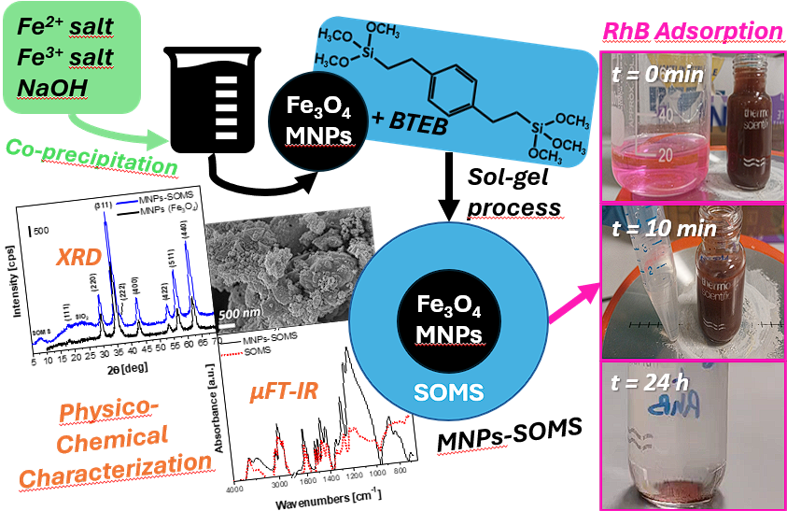
Figure 1. Scheme of MNPs-SOMS synthesis with examples of characterization analyses and images of RhB adsorption.

[1] A. S. Abdulhameed et al. J. of Polymers and the Environment 33 (2025) 1086-1105
[2] R. Wang et al. ChemistrySelect 9 (2024) 19
[3] L. Maccarino et al. Microporous and Mesoporous Materials 375 (2024) 113178
[4] A. Shahzad et al. Scientific Reports 14 (2024) 17674
[5] H. Li et al. Scientific Reports 14 (2024) 1217

