SWELLABLE HYBRID MATERIALS FOR THE ADSORPTION REMOVAL OF PERFLUOROALKYL SUBSTANCES FROM WATER

L. Maccarino,ª G. Paul,ª L. Marchese,ª C. Bisioª

ª Department of Science and Technological Innovation, Università del Piemonte Orientale, Viale Teresa Michel 11, Alessandria (AL), Italy
E-mail: lorenzo.maccarino@uniupo.it

Keywords: solid state NMR, solution NMR, materials.

Perfluoroalkyl substances (PFAS) are persistent chemicals with stable carbon-fluorine bonds that lead to their bioaccumulation and biomagnification in living organisms, causing adverse health effects in humans and other organisms, including weakened immune responses, hormone disruption, and elevated cholesterol. Detected globally in water sources, often above regulatory limits, PFAS necessitate effective remediation. Adsorbent materials like zeolites, activated carbons, and polymers are actively being researched for PFAS removal from water [1]. Swellable Organically Modified Silicas (SOMS), hybrid materials synthesized by sol-gel process using bis(trimethoxysilylethyl)benzene (BTEB), are a promising option for PFAS removal, due to their unique ability to swell in organic solvents, that enhances pollutant adsorption. SOMS can also be functionalized with positive quaternary amine silanes (QA-SOMS) to impart a positive charge [2,3]. The materials were characterized by a multi-analytical approach to investigate physico-chemical properties, such as elemental analysis, SEM, XRD, N₂ physisorption, TGA, ss-NMR and Z Potential measurements. From ¹H, ¹³C and ²⁹Si ss-NMR spectra it was possible to hypothesize a chemical structure (Fig. 1) and, from the latter, the degree of condensation of these materials. While HPLC is commonly used for PFAS detection, ¹⁹F NMR spectroscopy presents a promising alternative, due to ¹⁹F isotope's natural abundance and NMR activity, allowing nanogram-level detection of PFAS, if sample preconcentration is done [4]. SOMS and QA-SOMS materials have been tested for removing linear PFAS molecules, using ¹⁹F NMR spectroscopy to measure their concentrations in water.

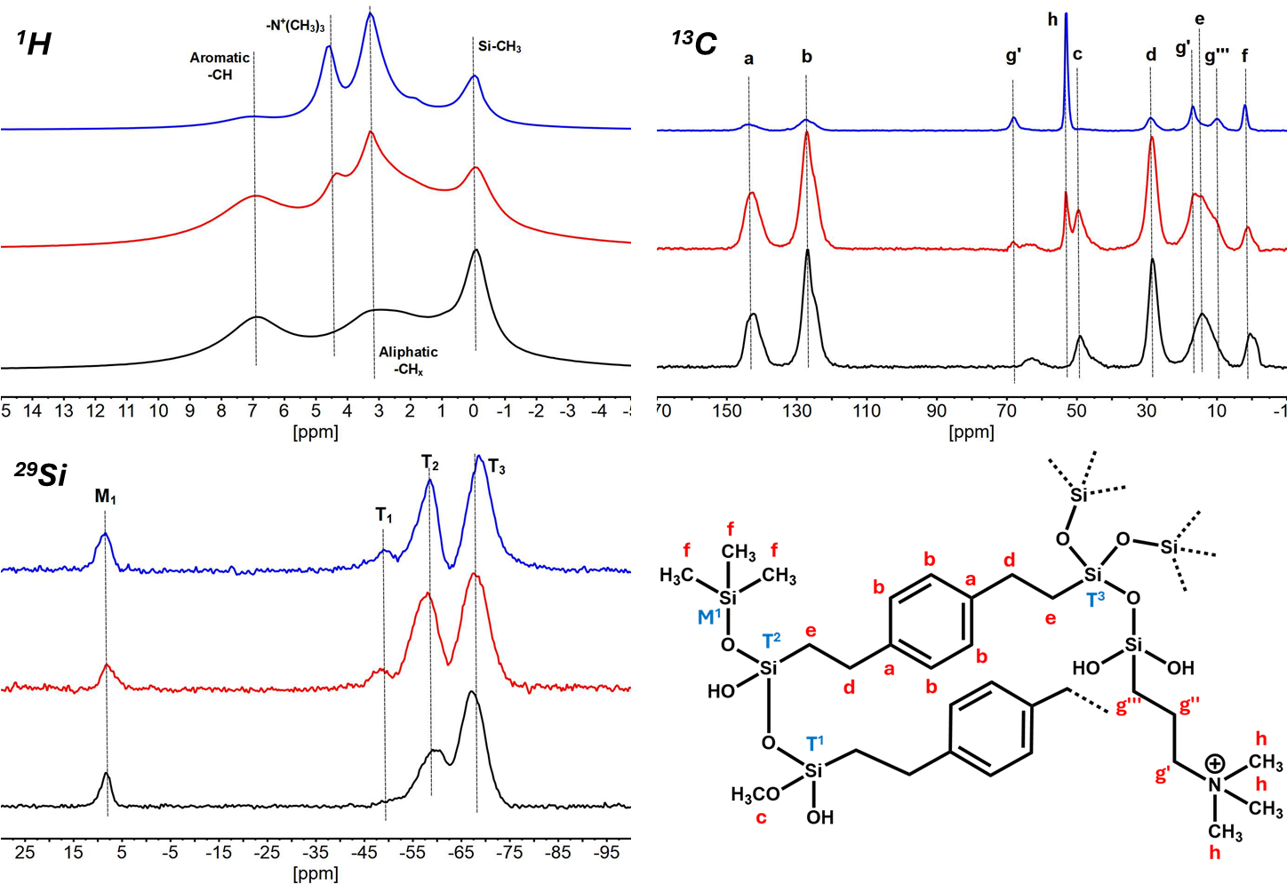
Fig. 1. ¹H (top-left), ¹³C (top-right) and ²⁹Si (bottom-left) ss-NMR spectra of SOMS (black), QA-SOMS 20 (red) and QA-SOMS 200 (blue) and a hypothesized chemical structure of materials (bottom-right).

References

[1] P. S. Pauletto et al., J. of Hazardous Mat., 425, 127810 (2022)
[2] V. Miglio et al., J. Phys. Chem. C, 128 (5), 2179-2189 (2024)
[3] E. K. Stebel et al., Environ. Sci.: Water Res. Technol., 5, 1854-1866 (2019)
[4] D. A. Ellis et al., Analytical Chemistry., 72 (4), 726-731 (2000)

