RELAXOMETRIC CHARACTERIZATION OF Functionalized derivatives of [Gd(AAZTA)(H₂O)₂]⁻ with aminoacids

M. Ricci, F. Carniato, M. Botta

Dipartimento di Scienze e Innovazione Tecnologica, Università del Piemonte Orientale Amedeo Avogadro, Viale T. Michel 11, Alessandria, Italy
E-mail: marco.ricci@.uniupo.it

The [Gd(AAZTA)(H₂O)₂]⁻ complex (AAZTA = 6-amino-6-methylperhydro-1,4-diazepine tetra acetic acid) is a platform of great interest for the design of new innovative MRI probes, due to its remarkable magnetic properties, thermodynamic stability, kinetic inertness, and high chemical versatility [1,2]. We developed some derivatives functionalized with amino acid residues (AAZTA-AA) with different molecular weight and charge. Three main reasons led to the choice of including amino acid residues in the ligand structure: (i) to evaluate the increase in efficacy (relaxivity) at the imaging fields (> 1 T) associated with the increase in the rotational correlation time; (ii) to promote non-covalent interactions with protein structures in biological environments, hence forming supramolecular adducts with high relaxivity; (iii) to study the properties of model compounds prior to synthesis of derivatives containing polypeptide residues for molecular imaging applications. The relaxometric properties of these chelates were analysed in order to determine their molecular parameters, which describe the paramagnetic relaxation mechanism. These were accurately assessed by simultaneous fitting of the ¹H NMRD profiles (in the 0.01-120 MHz range) and the ¹⁷O transverse relaxation rates (R₂) and shift (Δω) measured at 11.7 T and at different temperatures [3]. The relaxivity value of these chelates at 0.5 T is higher than that of the parent [Gd(AAZTA)(H₂O)₂]⁻, as a consequence of the increase of their reorientational correlation time (τ_{R}). Furthermore, tests in reconstituted human serum indicate an interaction with the proteins. Finally, the corresponding Eu(III) chelates were synthesized and characterized by ¹H NMR and time-resolved photoluminescence, in order to obtain structural information and determine the hydration state of metal ion.

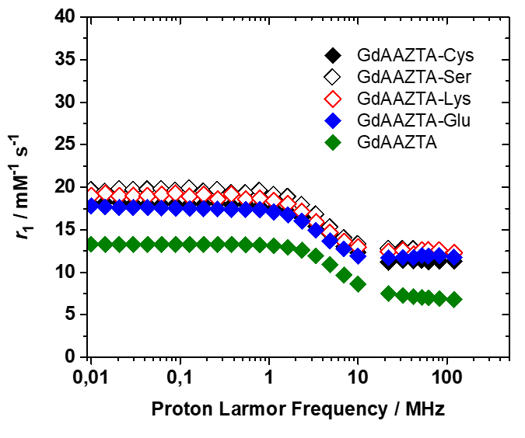

Fig. 1 and 2. From left to right, structure of the different AAZTA-AA ligands and ¹H NMRD profiles of [Gd(AAZTA)(H₂O)₂]⁻ and its derivatives at 298K.

References

[1] Aime, S., Calabi, L., Cavallotti, C., Gianolio, E., Giovenzana, G. B., Losi, P., Maiocchi, A., Palmisano, G., Sisti, M., Inorg. Chem. 43, 7588 (2004)
[2] Baranyai Z., Delli Castelli D., Tei L., Botta M., et al. Inorg. Chem. Front. 7, 795 (2020)
[3] Aime S., Botta M., Esteban-Gómez G., Platas-Iglesias C., Mol. Phys. 117, 898 (2019).

