Organo-modified silicas for the removal of dye molecules from water media

Lorenzo Maccarino¹, Vanessa Miglio¹, Leonardo Marchese¹, Chiara Bisio^{1,2}
¹ Dept of Sciences and Technological Innovation, University of Eastern Piedmont, viale T. Michel 11, 15121 Alessandria
² CNR-SCITEC Institute of Chemical Science and Technology “Giulio Natta”, Via G. Venezian 21, 20133 Milano
lorenzo.maccarino@uniupo.it

Many anthropogenic activities unfortunately introduce pollutant species that deteriorate the quality of water, one of the essential life components. Various methods can be used to remove pollutants from water (e.g., filtration, precipitation, electrochemical methods, bioremediation, catalysis, etc.), but adsorption onto solids (such as clays, zeolites, porous silicas) is considered an advantageous, cost-effective, and high-performance method [1]. For this purpose, interest was directed towards the study of an organic-inorganic hybrid silica material named Swellable Organically Modified Silica (Silica-SOM), which possesses the unique property of swelling, i.e., expanding porous volume under appropriate conditions, being potentially capable of storing significant amounts of pollutants [2]. Silica-SOM is synthesized by sol-gel method involving the polycondensation of bis(trimethoxysilylethyl)benzene using tetrabutylammonium fluoride as a catalyst. As the gel ages, a three-dimensional network of Si-O-Si bonds with aryl and aromatic groups forms, producing a porous and flexible material [3]. The physico-chemical properties of the Silica-SOM were determined by means of a multi-technique approach: the morphology was found to be composed of aggregates of particles of submicron size and irregular shapes; as Silica-SOM are hydrophobic, the particle size in aqueous suspension is higher (700 nm) than in organic solvents (< 250 nm), as they tend to aggregate in water; the material is mesoporous with a surface area of 414 m²/g and possesses a negative surface charge at pH values above 3.7.
The adsorption performance of Silica-SOM against two soluble organic dye pollutants in the aqueous phase (Rhodamine B and Methyl orange) was studied. Silica-SOM was placed in contact with an aqueous dye solution and the solutions were analyzed for successive times up to a maximum of 24 hours. Silica-SOM showed very promising removal capacities: after 1 hour of contact 99.5% of Rhodamine B (Fig. 1) and more than 98% of Methyl Orange (Fig. 2) was removed. Adsorption cycles of Rhodamine B were carried out, after desorption of the pollutant in alcohol solution by sonication. These tests showed that Silica-SOM is fully regenerable and reusable under the studied conditions.
Finally, the synthesis procedure of Silica-SOM was optimized using an experimental factorial design approach to decrease the synthesis time.
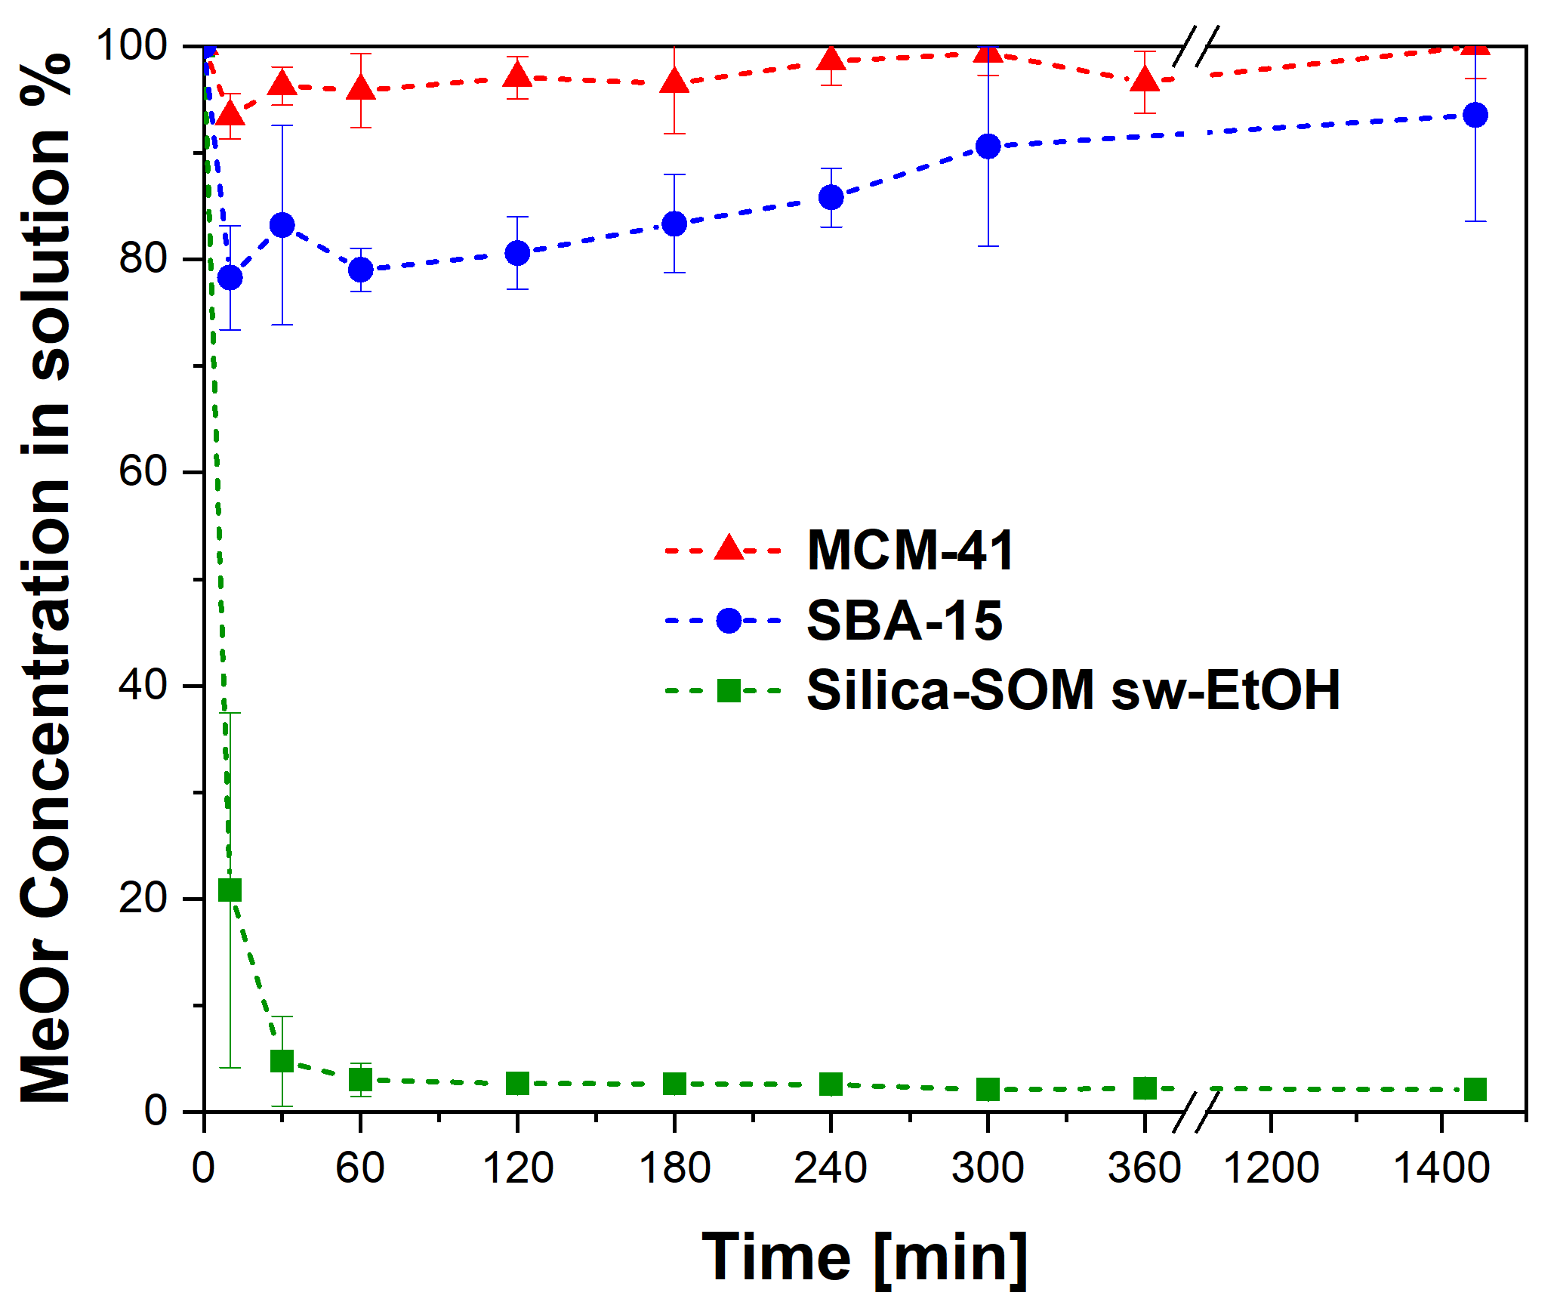
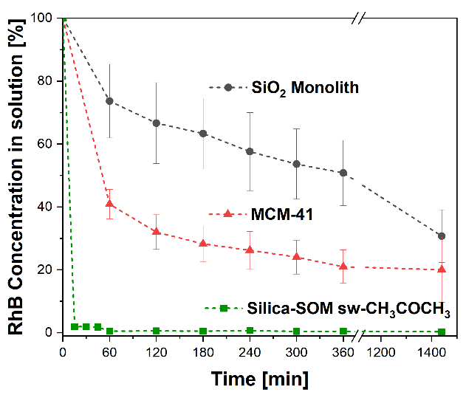
[1] Karthigadevi, G. et al. Bioresource Technology vol. 324, 124678, 2021
[2] C. M. Burkett e P. L. Edmiston, Journal of Non-Crystalline Solids, vol. 351, n. 40–42, pagg. 3174–3178, 2005
[3] P. L. Edmiston e L. A. Underwood, Separation and Purification Technology, vol. 66, n. 3, pagg. 532–540, 2009
Figure 2: Methylorange residual percentual concentration in solution over time. A comparison of different materials studied at same conditions: SBA-15 (●), MCM-41 (▲) and Silica-SOM pre-swollen with ethanol (∎).
Figure 1: Rhodamine B residual percentual concentration in solution over time. A comparison of different materials studied at same conditions: Silica monoliths (●), MCM-41 (▲) and Silica-SOM pre-swollen with acetone (∎).

